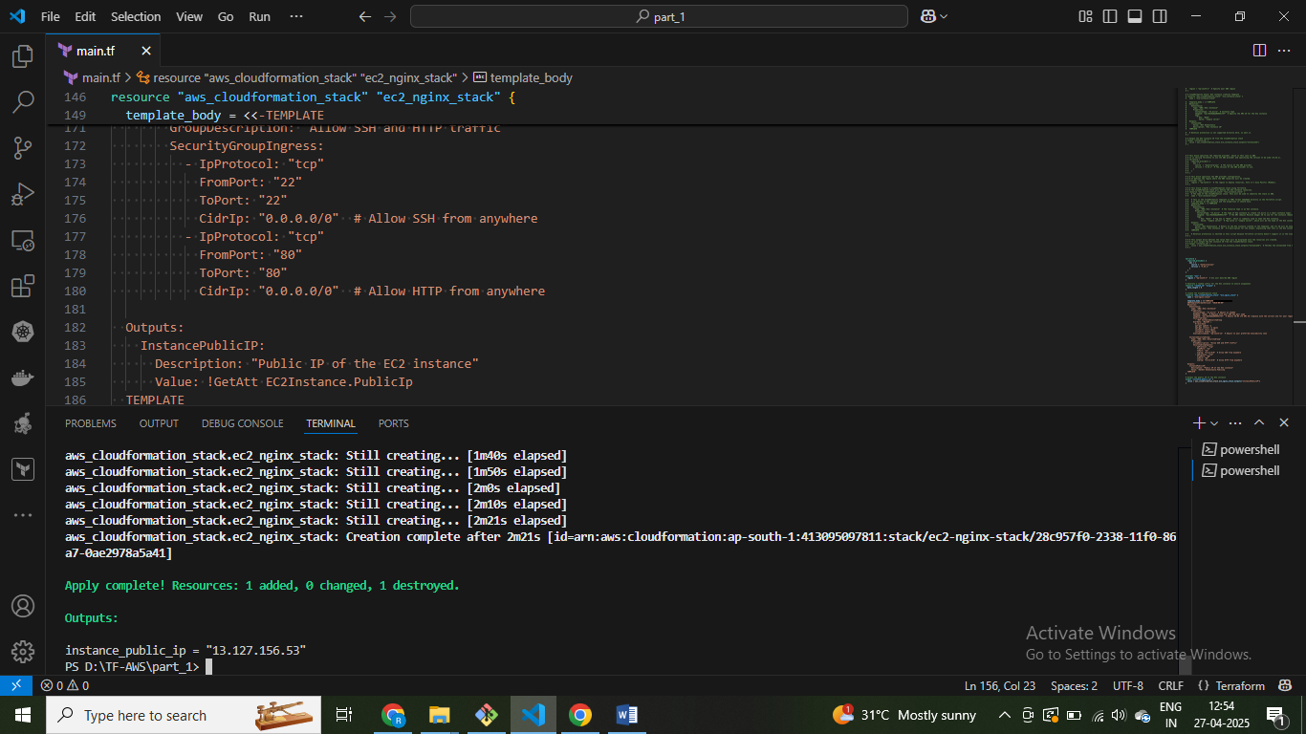

Resource completed successfully

Instance ip